TOWN OF ORCHARD PARK

S.4295 SOUTH BUFFALO STREET
ORCHARD PARK, NEW YORK 14127
(716) 662-6432
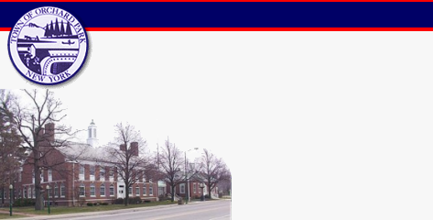
Architectural Overlay District (A.O.D.)
Application for Certificate of Appropriateness

A.O.D. File Number Date

Address of the Project/Property under consideration: , Orchard Park, New York 14127.

I (We), _________________________the petitioner(s) or authorized representative of the petitioner residing at hereby submit the above – referenced project/property to the A.O.D. Board for review and determination of appropriateness.

As directed and in accordance with Section 144-75 of the Town of Orchard Park Municipal Code (A.O.D), the petitioner shall describe his or her proposed intended scope of work relative to the designated project/property identified above. The petitioner shall also provide all specified materials as called for in Section 144-77, Paragraph C of the Municipal Code for review and approval. This shall be attached as Exhibit “A”.

The petitioner affirms under penalty of perjury that the information contained herein is true to the best of his or her knowledge.

Signed: ___________________________________________

Address: _________________________________________ , Orchard Park, NY 14127

Upon presentation of the proposed project to the A.O.D. Board, the board shall determine whether the project meets the design criteria of the code thereafter Approve, Reject or Table as a result of insufficient information.

Parking Lot

Board Action:

Initial Hearing Date: ______________________ Action: ___________________________

Second Date: ____________________________ Action: ___________________________

Third Date: _____________________________ Action: ___________________________

Final Board Determination: ____________________ Date: ___________________________

Certificate of Appropriateness: ___________________ Granted _____________________Denied

___________________________________________
Chairman – Architectural Overlay District

Distribution: Steven Bremer, Building Inspector
Planning Office
Deputy Town Attorney John Bailey

